Mia Čarapina

Vierchai

Interface for questions

Technical Specification

Version: | 1.0
Author: | Vierchai
Date: | 6/6/2017

Table of Contents
1. Version Control 3
2. Distribution List 3
3. Project description 4
4. Technology 4
4.1. Development Tools 4
5. Wireframes (Storyboards) 5
6. User Interface Specification 7
6.1. Navigation 7
6.1.1. Homepage navigation 7
6.1.2. Posting page navigation 7
6.1.3. Answering page 7
6.1.4. Analyze page 7
6.2. Single page (section) specification 7
6.2.1. Homepage 7
6.2.2. Posting page 8
7.2.3 Answering page 8
7. Testing 8
7.1. List of functions tested 8
7.2. Results 9
8. Troubleshooting Guide 10

Version Control
The following is a list all changes made to this document, the person making the change, the new version number and the reason why the change was necessary.

Date | Author | Version | Change Description
3/6/2017 | Renata Tremski | 1.0 | Start of the documentation
4/6/2017 | Kipras Gabrielaitis | 1.1 | Descriptions of the wireframes
10/6/2017 | Tena Kuhar, Mihael Velički | 1.2 | Navigation and single page specification
11/6/2017 | Iva Nekić | 1.3 | Conclusion and testing results

Distribution List
The following list contains the names and organisational details of the people to whom this document has been distributed.

Name | Organization | Position
Mia Čarapina | Zagreb University of Applied Sciences | Professor

Project description

Web application that enables the user to post questions to a specific audience, collect answers, analyze and archive them.

Technology

HTML5, CSS3, JavaScript.

Development Tools
Photoshop CS4, Notepad++

Wireframes (Storyboards)

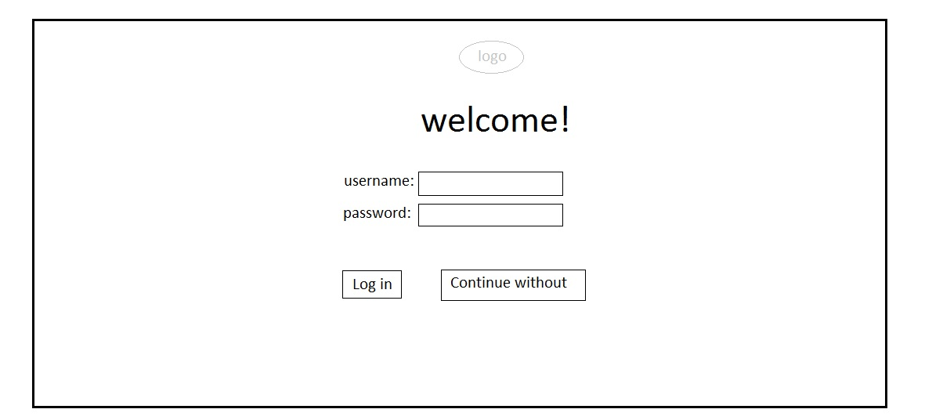
Picture 1: Homepage for logging in – the first that the user opens. The user can choose to login or not. If the user is the professor and wants to post questions, he/she must log in. The users who answer questions can continue without logging in to the answering page.
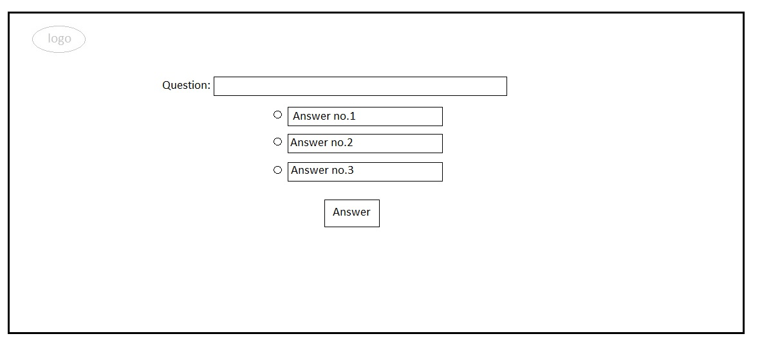
Picture 2: Page for answering questions – the page where users answer the posted questions. The question is displayed as well as the possible answers (in different forms, depending on what the professor posted).
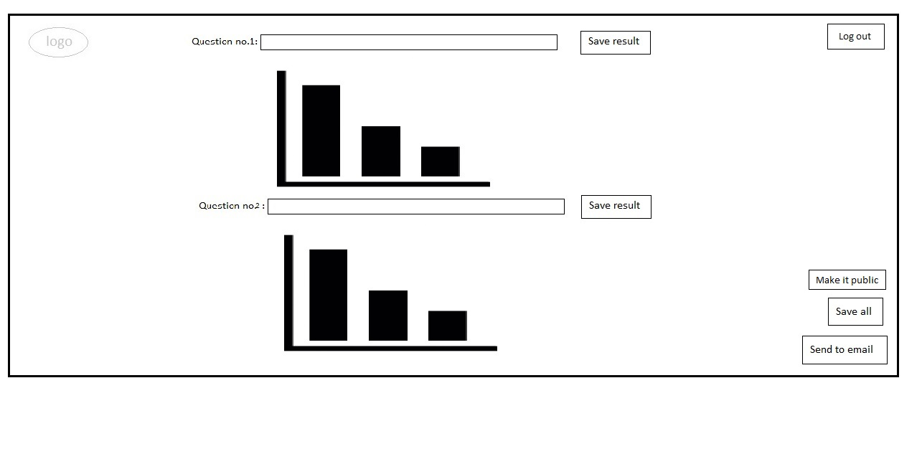
Picture 3: Page for showing results – the results are displayed in the form of a chart. The professor can view the results privately or make them public to show to the users who answered. They can save each individual result or all of them at once to the hard drive and/or send them via email.

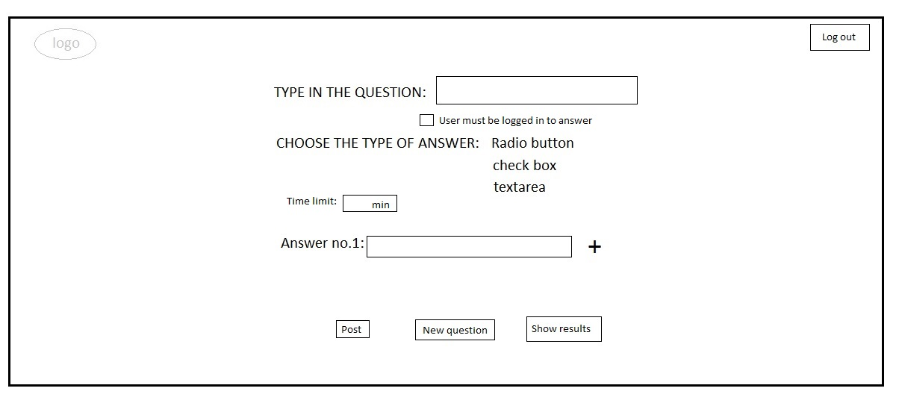
Picture 4: Page for creating questions – the professor types in the question, chooses if the users must be logged in to answer and the type of answer the user must input (radio button, check box or text area). There is an option for setting a time limit for answering (in minutes). Then the professor inputs the answer or multiple answers (adding answers with the plus button). After posting the question, the professor can post another one or go to the results.

User Interface Specification

- Navigation:
The website doesn’t have a navigation, the user navigates through the pages depending on the option he/she chooses (by clicking the available buttons).

Navigation

Homepage navigation
On the home page there are two options through which the users navigate to the other pages. The first one is the login button which navigates the user depending on the login information provided – if the user is a student the page redirects them to the page for answering questions. But if the user provided the professor login information, the page redirects them to the page for creating questions.
The other option is to continue without logging in, which navigates the user to the page for answering questions.

Posting page navigation
The page for creating and posting questions has the show results button that leads the professor to the page that displays the results and the log out button which takes them back to the homepage.

Answering page
On the page for answering questions, there is a button that submits the users answer and navigates the user back to the homepage.

Analyze page
On the page for analyzing results the log out button navigates the user back to the homepage.

Single page (section) specification

Homepage
Homepage: To post a question the professor needs to log in. Once that is done, the page redirects to the page for posting questions (posting.html).
Depending on the question requirement the student may need to log in to answer the question or continue without logging in.

Posting page

After logging in, user is redirected to this page and have possibility to create a question and choose type of answers, time limitations for answering, define if the user needs to be logged in to access the answer page.

Answering page

Depending on the question requirement, user logs in or accesses answering page without providing account information. Once user is(isn't) logged in he can answer the posted question by typing or choosing one of the offered answers.

    - Analizing page

After the answers are submitted, professor can access the analyzing page from the posting one by clicking on “show results” which redirects to the analyzing page. These results can be downloaded on computer, sent on email or can be made public for all users.

Testing

Period: | 3.- 11. 6. 2017.

List of functions tested

No. | Functionality | Goals of testing
1 | Home page – Continue without | Test the functionalities of the Continue without button, if it navigates to the correct page
2 | Posting page - “Post” | Verifying the performance of the navigation.  “Post” button should return the user to the posting page
3 | Posting page - ”Show results” | ”Show results” button is supposed to lead to the analyzing page
4 | Posting page – “Log out” | “Log out” button leads to the homepage
5 | Analyzing page - “Log out” | Checking the performance of the buttons on the page, “Log out” is supposed to take the user back to the index
6 | Analyzing page - “Send to email“ | “Send to email” should open outlook

Results

No. | Result and comments
1 | “Continue without” button leads to answering page
2 | “Post” button returns the user to the posting page
3 | ”Show results” button leads to the analyzing page
4 | “Log out” button leads to the homepage.
5 | “Log out” takes the user back to the index
6 | “Send to email“ opens the outlook program on the computer

Overall result (conclusion):
Tested functionalities show great results and connections between them (buttons) work.

Troubleshooting Guide

The website is not fully functional because the backend is not yet implemented. Our future goals are to finish the backend once we have more knowledge about that area. The missing components include verification of users to distinguish professors and students, which will enable the application to redirect professors to the posting page and the students only to the answering one.
Posting page is not yet able to connect with the answering page in a way which will make the posted question available to be answered.
The answering page requires a database to function properly.
And the analyzing page the current graphs are just placeholders until the answers can be stored in a database to be able to be analyzed.

